# Lab1 Report

Poju Huang 1.30.2023

Code:

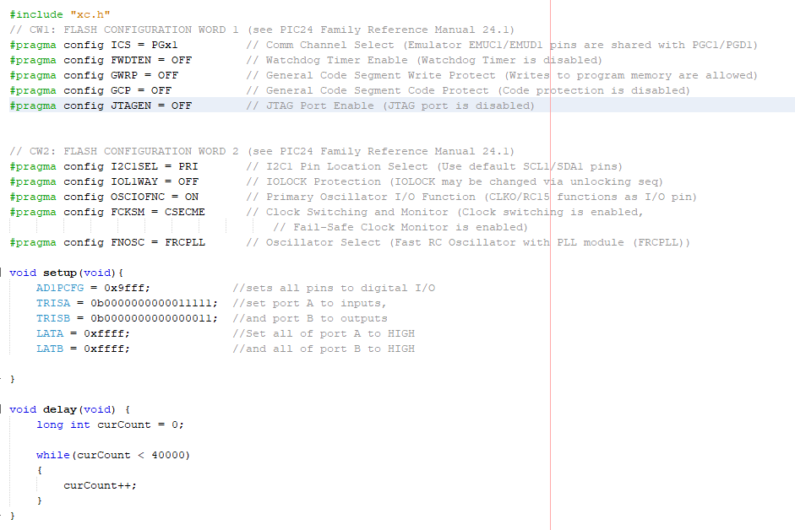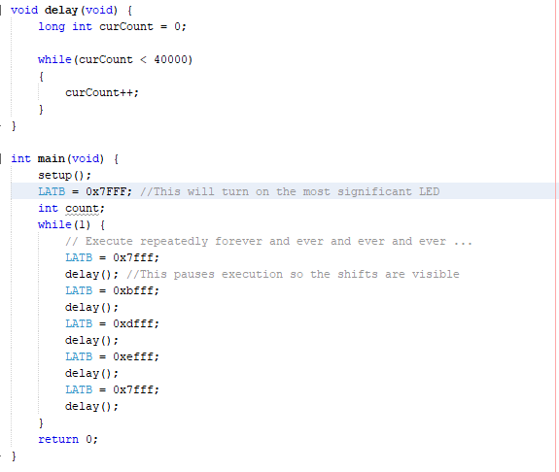

Questions:

Q1:

In order to shift our LED, we have to shift the bit to the right by one bit, and do the or computation with 0x8000, in order to get 1 at the most significant bit(the far most left one).

Q2:

For example, the number we want to convert is 0xA8

LATB = 0xA8

LATB =^ 0x80

Q3:

Because we are using int variable and it overflowed. We can change the number for example curCount < 4000 (however this time interval will be too small) or we can change the type of the variable, for example change it to long int.

Q4:

Because the direction of current is flowing from high voltage to low voltage, and if we want the led to glow, there must be current flowing through it. For example, we have 4 LEDs, R0 R1 R2 R3, and we want R1 to glow, so we need 1011 in order to make a current through R1.